# Lab: Objects and Classes

Problems for exercises and homework for the [“Programming Fundamentals” course @ SoftUni](https://softuni.bg/courses/programming-fundamentals).

You can check your solutions here: <https://judge.softuni.bg/Contests/175/Objects-and-Classes-Lab>.

# Using the Built-in .NET Classes

## Day of Week

You are given a **date** in format **day-month-year**. Calculate and print the **day of week** in **English**.

### Examples

|  |  |
| --- | --- |
| **Input** | **Output** |
| 18-04-2016 | Monday |
| 27-11-1996 | Wednesday |

### Hints

* **Read the date as string** from the Console.
* Use the method [**DateTime.ParseExact(string date, format, provider)**](https://msdn.microsoft.com/en-us/library/w2sa9yss(v=vs.110).aspx) to convert the input string to object of typeDateTime. Use format **“**d-M-yyyy**”** and CultureInfo.InvariantCulture.
  + Alternatively split the input by “-“ and you will get the day, month and year as numbers. Now you can create new DateTime(year, month, day).
* The newly created DateTime object has property [**DayOfWeek**](https://msdn.microsoft.com/en-us/library/system.datetime.dayofweek(v=vs.110).aspx).

## Randomize Words

You are given a **list of words in one line**. **Randomize their order** and print each word at a separate line.

### Examples

|  |  |  |
| --- | --- | --- |
| **Input** | **Output** | **Comments** |
| Welcome to SoftUni and have fun learning programming | learning  Welcome  SoftUni  and  fun  programming  have  to | The order of the words in the output will be different after each program execution. |

### Hints

* **Split** the input string by (space) and create an **array of words**.
* Create a random number generator – an object rnd of type **Random**.
* In a **for-loop exchange each number** at positions 0, 1, … words.Length-1 by a number at **random position**. To generate a random number in rangeuse **rnd.**[**Next(minValue, maxValue)**](https://msdn.microsoft.com/en-us/library/2dx6wyd4(v=vs.110).aspx). Note that by definition minValue is **inclusive**, but maxValue is **exclusive**.
* Print each word in the array on new line.

## Big Factorial

Calculate and print n! (n factorial) for very big integer n (e.g. 1000).

### Examples

|  |  |
| --- | --- |
| **Input** | **Output** |
| 5 | 120 |
| 50 | 3041409320171337804361260816606476884437764156896051200000000000 |

### Hints

Use the class BigIntegerfrom the built-in .NET library System.Numerics.dll.

1. Add reference to System.Numerics.dll.

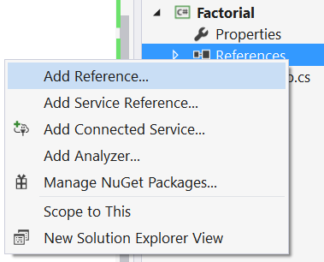

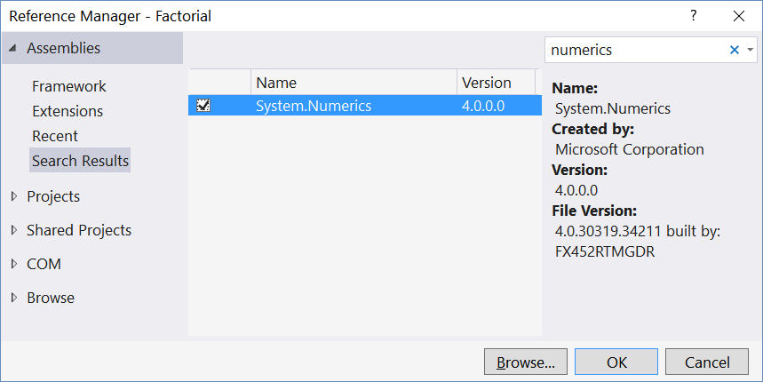

1. Import the namespace “System.Numerics”:



1. Use the type BigInteger instead of long or decimal to keep the factorial value:

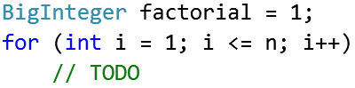

# Defining Simple Classes

## Distance Between Points

Write a method to calculate the distance between two points **p1** {**x1**, **y1**} and **p2** {**x2**, **y2**}. Write a program to read **two points** (given as two integers) and print the **Euclidean distance** between them.

### Examples

|  |  |
| --- | --- |
| **Input** | **Output** |
| 3 4  6 8 | 5.000 |
| 3 4  5 4 | 2.000 |
| 8 -2  -1 5 | 11.402 |

### Hints

* Create a **class** Point holding properties X and Y.
* Write a method CalcDistance(Point p1, Point p2) that returns the distance between the given points – a double number.
* Use [this formula](http://www.cut-the-knot.org/pythagoras/DistanceFormula.shtml) to calculate the distance between two points. How it works?
  + Let's have two points **p1** {**x1**, **y1**} and **p2** {**x2**, **y2**}
  + Draw a right-angled triangle
  + Side **a = |x1 - x2|**
  + Side **b = |y1 - y2|**
  + Distance == side **c** (hypotenuse)
  + **c2** = **a2** + **b2** (Pythagorean theorem)
  + Distance = **c** = $\sqrt{a^{2}+b^{2}}$

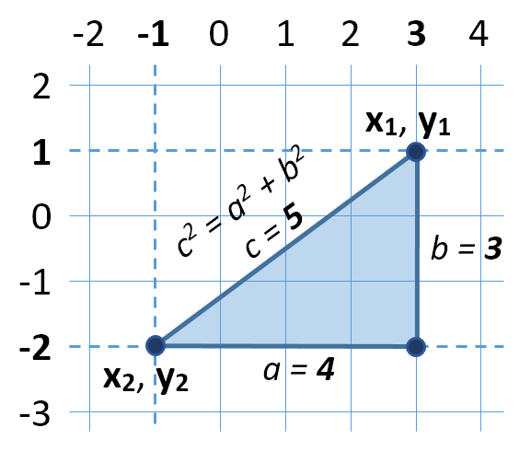

* You can use [**Math.Sqrt(number)**](https://msdn.microsoft.com/en-us/library/system.math.sqrt(v=vs.90).aspx) method for calculating a square root.

## Closest Two Points

Write a program to read **n** points and find the **closest two** of them.

### Input

The **input** holds the number of points n and n lines, each holding a point {X and Y coordinate}.

### Output

* The **output** holds the shortest distance and the closest two points.
* If several pairs of points are equally close, print **the first** of them (from top to bottom).

### Examples

|  |  |  |  |
| --- | --- | --- | --- |
| **Input** | **Output** | **Visualization** | **Comments** |
| 4  3 4  6 8  2 5  -1 3 | 1.414  (3, 4)  (2, 5) |  | The closest two points are **{3, 4}** and **{2, 5}** at distance 1.4142135623731 ≈ **1.414**. |
| 3  12 -30  6 18  6 18 | 0.000  (6, 18)  (6, 18) |  | Two of the points have the same coordinates **{6, 18}**, so the distance between them is **0**. |
| 3  1 1  2 2  3 3 | 1.414  (1, 1)  (2, 2) |  | The pairs of points {{1, 1}, {2, 2}} and {{2,2}, {3,3}} stay at the same distance, but the first pair is {**{1, 1}**, **{2, 2}**}. The distance between them is 1.4142135623731 ≈ **1.414**. |

### Hints

* Use the **class** Point you created in the previous task.
* Create an array Point[]points that will keep all points.
* Create a method Point[]FindClosestPoints(Point[] points) that will check distance **between every two pairs** from the array of points and returns the two closest points in a new array.
* Print the **closest distance** and the **coordinates** of the two closest points.

## Rectangle Position

Write a program to **read two rectangles** {left, top, width, height} and print whether the first is inside the second.

The input is given as two lines, each holding a rectangle, described by 4 integers: **left**, **top**, **width** and **height**.

### Examples

|  |  |  |  |
| --- | --- | --- | --- |
| **Input** | **Output** | **Visualization** | **Comments** |
| 4 -3 6 4  2 -3 10 6 | Inside |  | The first rectangle stays **inside** the second. |
| 2 -3 10 6  4 -5 6 10 | Not inside |  | The rectangles intersect, no the first is **not insid**e the second. |

### Hints

* Create a class Rectangle holding properties Top, Left, Width and Height.
* Define calculated properties Right and Bottom.
* Define a method bool IsInside(Rectangle r). A rectangle r1 is inside another rectangle r2 when:
  + r1.Left ≥ r2.Left
  + r1.Right ≤ r2.Right
  + r1.Top ≤ r2.Top
  + r1.Bottom ≤ r2.Bottom
* Create a method to **read** a Rectangle.
* Combine all methods into a single program.

## Sales Report

Write a class Sale holding the following data: **town**, **product**, **price**, **quantity**. Read a **list of sales** and calculate and print the **total sales by town** as shown in the output. Order **alphabetically** the towns in the output.

### Examples

|  |  |  |
| --- | --- | --- |
| **Input** | **Output** | **Comments** |
| 5  Sofia beer 1.20 160  Varna chocolate 2.35 86  Sofia coffee 0.40 853  Varna apple 0.86 75.44  Plovdiv beer 1.10 88 | Plovdiv -> 96.80  Sofia -> 533.20  Varna -> 266.98 | Plovdiv -> 1.10 * 88 = 96.80  Sofia -> 1.20 * 160 + 0.40 * 853 = 533.20  Varna -> 2.35 * 86 + 0.86 * 75.44 = 266.98 |

### Hints

* Define the class Sale holding properties Town, Product, Price and Quantity.
* Create a method ReadSale() that reads a sale data line from the console and returns Sale object. It could split the input line by space and parse the price and quantity.
* To read the input, first read an integer n, then n times read a sale.
* **Approach I – LINQ**
  + Using **LINQ** select the **distinct town names** from the array of sales and sort them.
  + For **each town** in a loop use a LINQ query to calculate the **total sales** (aggregate the sum of **price** * **quantity** for all sales by the current town).
* **Approach II – Dictionary {town 🡪 sales}**
  + Define a dictionary SortedDictionary<string, decimal> salesByTown to hold the total sales for each town.
  + Pass through all the sales from the input in a loop and for each sale, add its **price** * **quantity** to the salesByTown for the current town. If the town is missing in the dictionary, first create it.
  + Finally print the dictionary.
* The second approach is faster, because it scans the array of sales only once.